Regulations:
A14

H.T No

Sreenidhi Institute of Science and Technology
(An Autonomous Institution)
Code No: 4AC41 Date: 11-June-2019 (FN)

B.Tech I-Year II-Semester External Examination, June-2019 (Supplementary)
BASIC Electrical Engineering (BT)

Time: 3 Hours Max.Marks:70

Note: a) No additional answer sheets will be provided.
b) All sub-parts of a question must be answered at one place only, otherwise it will not be valued.
c) Missing data can be assumed suitably.

Part - A Max.Marks:20

Answer all QUESTIONS.

1. | State Ohm’s Law and write its limitations. | [2M]
2. | Explain the terms RMS value, Form Factor and Peak factor. | [2M]
3. | Derive the torque equation of a D.C Motor. | [2M]
4. | Define regulation of a transformer? | [2M]
5. | Obtain the relation between phase voltages and line voltages in a delta connected system. | [2M]
6. | List the advantages of PMMC instruments. | [2M]
7. | State Faraday’s Laws of Electromagnetic Induction. | [2M]
8. | A 220V, D.C. series generator has constant loss of 300W and an armature resistance of 0.15Ω. Determine the load current at maximum efficiency. | [2M]
9. | A three phase induction motor is wound for 4 poles and is supplied from 50Hz supply. Calculate (i) Synchronous speed, (ii) rotor speed when running at a slip of 4%. | [2M]
10. | State Thevenin’s Theorem. | [2M]
Part – B Max.Marks:50
ANSWER ANY FIVE QUESTIONS. EACH QUESTION CARRIES 10 MARKS.

11. | a) | State and explain Kirchhoff's laws. | [5M]
 | b) | Determine the current through 1Ω resistor in Fig. 1 using mesh analysis.  Fig. 1 | [5M]
12. | a) | Define the following terms:  (i) Instantaneous value (ii) Cycle (iii) Time period (iv) Frequency | [4M]
 | b) | A two element series circuit is connected across an A.C source  The current in the circuit is then found to be )A.  Determine the parameters of the circuit. | [6M]
13. | a) | Derive the EMF equation of a D.C generator. | [4M]
 | b) | A 4 pole, lap wound D.C shunt generator has a useful flux per pole of 0.07Wb. The armature winding consists of 220 turns with an effective resistance of 0.1Ω. Calculate the terminal voltage when running at a speed of 900rpm and drawing an armature current of 50A. | [6M]
14. |  | A 10kVA, 450/120V, 50Hz single phase transformer gave the following test results:  Open circuit test: V_{o} = 120V, I_{o} = 4.2A, W_{o} = 80W  Short circuit test: V_{sc} = 9.65V, I_{sc} = 22.2A, W_{sc} = 120W  i) Find the equivalent circuit referred to Low voltage side.  ii) Determine the voltage regulation at 80% full load, 0.85 power factor lagging. | [10M]
15. |  | Derive the expression for total power input for a star connected balanced three phase load interms of line voltage, line current and power factor with the help of respective phasor diagrams. | [10M]
16. | a) | Discuss about the construction and principle of operation of Moving Iron(MI) instruments with neat sketch. | [6M]
 | b) | Write the advantages and disadvantages of MI instruments. | [4M]
17. | a) | 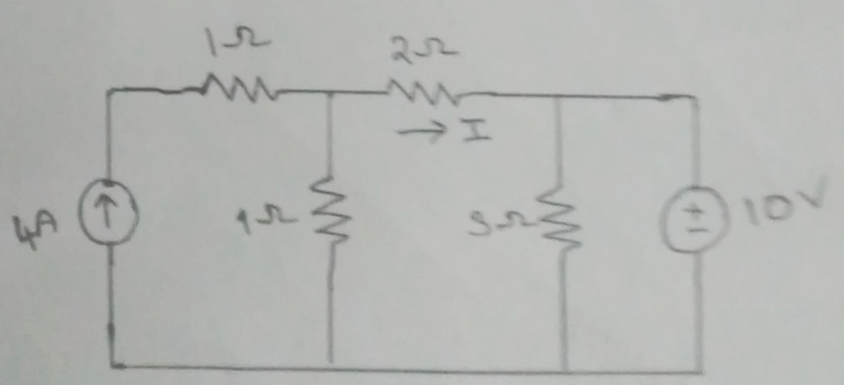  Determine the current “I” in the network shown in Fig. 2 using Superposition Theorem.  Fig. 2 | [6M]
 | b) | Explain about the internal and external characteristics of a D.C shunt generator. | [4M]
18. | a) | Explain the operation of a transformer on no – load and on – load with necessary phasor diagrams. | [6M]
 | b) | Explain how the range of an ammeter is extended using necessary equations. | [4M]

-- 00 -- 00 –

